

**GROUP MEMBERS:**

1. Ammar Siddiqui (20k-0177)
2. Muaz Zafar (20k-0363)
3. Huzaifa Tanzeel (20k-0305)
4. Aitizaz Ahmed (20k-1734)

**Department:** Computer Science

**Batch:** Spring 2021

**Section:** **E**

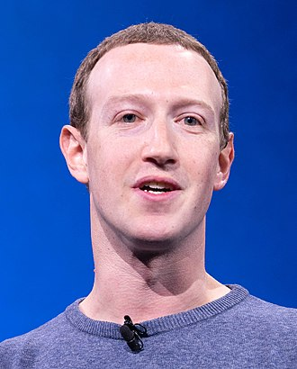**MARK ZUCKERBERG**

Link: <https://www.youtube.com/watch?v=ouE6qyTc-l0>

Mark Zuckerberg is the CEO and founder of one of the pioneer social media app “Facebook”. We all know of him as the CEO of various social media apps, but as we all know that the success of any idea lies upon its conveying to the masses. Similarly, here we are taking an example of his speech which was given in 2016 on the occasion of the F8 annual Facebook conference.

The first point in this regard is his gestures. He looked confident as he knew what he is going to talk about. He didn’t bring any written form with him to aid him in the speech. He kept his hands in front all the time during the speech which is a positive sign for any speaker.

The second part is his voice during the speech. He paused several times in his speech, indicating that his first idea is finished and now he is moving to another. He paused in this way every time he conveyed a new idea and this pause is not filled with any kind of fillers that may sound unprofessional.

The third part is the use of visual aid. Here he just showed one line and he explained the line to the audience while looking continuously at the audience and not looking back at the lines. He used the visual aid in a great way and did not over burden the slides.

These are the aspects that are essential for any good public speaker to convey and convince the people around him on any particular idea. This speech here tells us the qualities of Mark Zuckerberg as a public speaker and how is he able to hold a business like Facebook at this young age and of course the reason behind his success.